**COURSE NAME**

**Al**

**LAB No: 03**

**Submitted To:**

**Sir. Maryam**

**Submitted By:**

**Student_Name**

**FA20-BSai-044**

**Submission Date: 28 Sep, 2021**

**DEPARTMENT OF Computer Science**

**SIR SYED CASE INSTITUTE OF TECHNOLOGY, ISLAMABAD**

**LAB No – 03**

**Task 1: Question:**

**Write a function to check if a string is empty or not. If not, count the total number of vowels, consonants and blank spaces in a string.**

**Code/Solution:**

def check(str1):

    v = 0

    s=0

    c = 0

    for i in str1:

        if(i == 'a' or i == 'e' or i == 'i' or i == 'o' or i == 'u'

        or i == 'A' or i == 'E' or i == 'I' or i == 'O' or i == 'U'):

            v = v + 1

        elif i==" ":

            s=s+1

        else:

            c = c + 1

    print(f"Total Number of Vowels in this String = {v}")

    print(f"Total Number of Consonants in this String = {c}")

    print(f"Total Number of Space in this String = {s}")

string = input("Please Enter Your String : ")

if len(string)> 0:

    check(string)

else:

    print("Your list is empty")

**Output:**

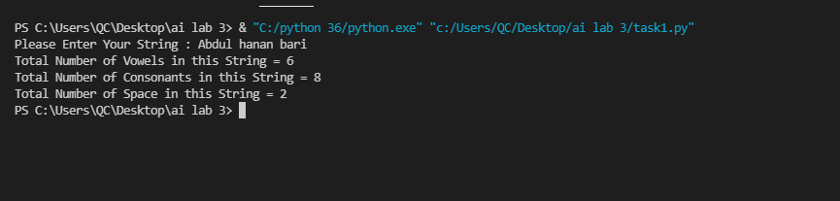

**Task 2: Question:**

**Write a method to calculate Fibonacci series up to ‘n’ points. After calculating the series, the method should return it to main function. The Fibonacci sequence is a series of numbers where a number is found by adding up the two numbers before it. Starting with 0 and 1, the sequence goes 0, 1, 1, 2, 3, 5, 8, 13, 21, 34, and so forth**

**Code/Solution:**

def rao(n):

    if n==1:

        return 0

    elif n==2:

        return 1

    else:

        return rao(n-1) + rao(n-2)

n=int(input("enter your number :"))

for i in range(1,n):

    c=rao(i)

    print(c)

**Output:**

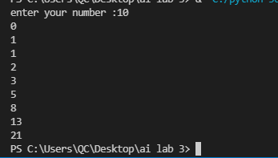

**Task 3: Question:**

**Write a function that reverses the characters in a string. (It can be considered a string copy, starting from the back end of the first string.)**

**Code/Solution:**

str1 = input("Please Enter Your String : ")

num=int(len(str1))-1

while num>=0:

    print(str1[num])

    num=num-1

**Output:**

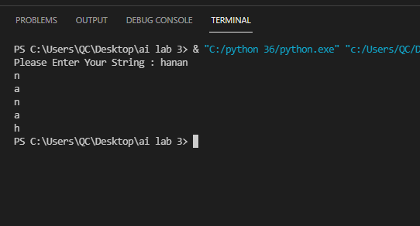

**Task4:**

**write a program that lets the user enter in some English text, then converts the text to PigLatin. To review, Pig-Latin takes the first letter of a word, puts it at the end, and appends “ay”. The only exception is if the first letter is a vowel, in which case we keep it as it is and append “hay” to the end. E.g., “hello” -> “ellohay”, and “image” -> “imagehay” Hint: Split the entered string through split() method and then iterate over the resultant list, e.g. “My name is John Smith”.split(“ ”) -> [“My”, “name”, “is”, “John”, “Smith”]**

**Code:**

str1 = input("Please Enter Your String : ")

list1=str1.split(" ")

print(list1)

for item in list1:

    i=item[0]

    if(i == 'a' or i == 'e' or i == 'i' or i == 'o' or i == 'u'

        or i == 'A' or i == 'E' or i == 'I' or i == 'O' or i == 'U'):

        ab=item+"hay"

        print(ab)

        print("\n")

    else:

        fin=""

        for it in item:

            if it==item[0]:

                pass

            else:

                fin=fin+it

        fin=fin+item[0]+"ay"

        print(fin)

        print("\n")

**Output:**

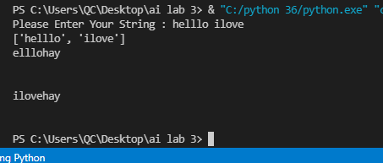

**Task 5:**

**Write a Python script to print a dictionary where the keys are numbers between 1 and 10 (both included) and the values are square of keys. Sample Dictionary: {1: 1, 2: 4, 3: 9, 4: 16, 5: 25, 6: 36, 7: 49, 8: 64, 9: 81, 10: 100}**

**Code:**

rao={}

n=int(input("enter your number :"))

for i in range(1,n+1):

    rao[i]=i*i

print(rao)

**output:**

